What is Induction?
Induction is the magnetic field which is proportional to the rate of change of the magnetic field. This definition of induction holds for a conductor. Induction is also known as inductance. L is used to represent the inductance and Henry is the SI unit of inductance.
1 Henry is defined as the amount of inductance required to produce an e.m.f. of 1 volt in a conductor when the current change in the conductor is at the rate of 1 Ampere per second.

Factors Affecting Inductance
Following are the factors that affect the inductance:
- The number of turns of the wire used in the inductor.
- The material used in the core.
- The shape of the core.
Electromagnetic Induction law was given by Faraday which states that by varying the magnetic flux electromotive force is induced in the circuit. From Faraday’s law of electromagnetic induction, the concept of induction is derived. Inductance can be defined as the electromotive force generated to oppose the change in current in a particular time duration.

According to Faraday’s Law:
Electromotive force = – L ΔI/Δt
Unit of Inductance = Volt Second/Ampere=Henry

Types of Inductance
Two types of inductance are there:
- Self Induction
- Mutual Induction
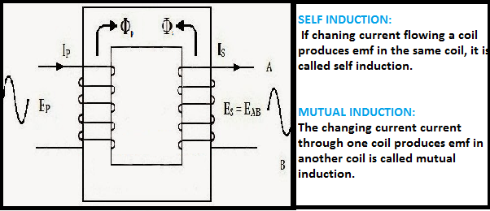

What is Self-Induction?
When there is a change in the current or magnetic flux of the coil, an opposed induced electromotive force is produced. This phenomenon is termed as Self Induction. When the current starts flowing through the coil at any instant, it is found that that the magnetic flux becomes directly proportional to the current passing through the circuit. The relation is given as:
ϕ= I
ϕ = L I
Where L is termed as self-inductance of the coil or the coefficient of self-inductance. The self-inductance depends on the cross-sectional area, the permeability of the material or the number of turns in the coil.
The rate of change of magnetic flux in the coil is given as,
e = – dϕ/dt = – d(LI)/dt
or e = – L dI/dt

Self Inductance Formula
L = (Nϕ)/I
Where,
- L is the self-inductance in Henry
- N is the number of turns
- Φ is the magnetic flux
- I is the current in amperes

What is Mutual Induction?
We take two coils, and they are placed close to each other. The two coils are P- coil (Primary coil) and S- coil (Secondary coil). To the P-coil, a battery, and a key is connected wherein the S-coil a galvanometer is connected across it. When there is a change in the current or magnetic flux linked with two coils an opposing electromotive force is produced across each coil, and this phenomenon is termed as Mutual Induction. The relation is given as:
ϕ = I
ϕ = M I
Where M is termed as the mutual inductance of the two coils or the coefficient of the mutual inductance of the two coils.
The rate of change of magnetic flux in the coil is given as,
e = – dϕ/dt = – d(MI)/dt
e = – M dI/dt

Mutual Inductance Formula
M = (μ₀μ_{r}N₁N₂A)/l
Where,
- μ₀ is the permeability of free space
- μ_{r} is the relative permeability of the soft iron core
- N is the number of turns in coil
- A is the cross-sectional area in m²
- l is the length of the coil in m

Difference between Self and Mutual Inductance

Self induction | Mutual induction
Self inductance is the characteristic of the coil itself. | Mutual inductance is the characteristic of a pair of coils.
The induced current opposes the decay of current in the coil when the main current in the coil decreases. | The induced current developed in the neighboring coil opposes the decay of the current in the coil when the main current in the coil decreases.
The induced current opposes the growth of current in the coil, when the main current in the coil increases. | The induced current developed in the neighboring coil opposes the growth of current in the coil when the main current in the coil increases.

